

|  |  |  |  |  |  |  |  |  |
| --- | --- | --- | --- | --- | --- | --- | --- | --- |
|  | | | | | | | | |
|  | | University Management Report | | | | |  | |
|  |  | | | | | | |  |
|  | | | |  |  | | | |
|  | | | | Basil Ali Khan |  | | | |
|  | | | | 9 September 2022—Software Design and Analysis—Eng. Abdul Rahman |  | | | |
|  | | |  | | |  | | |

**Question#02:**

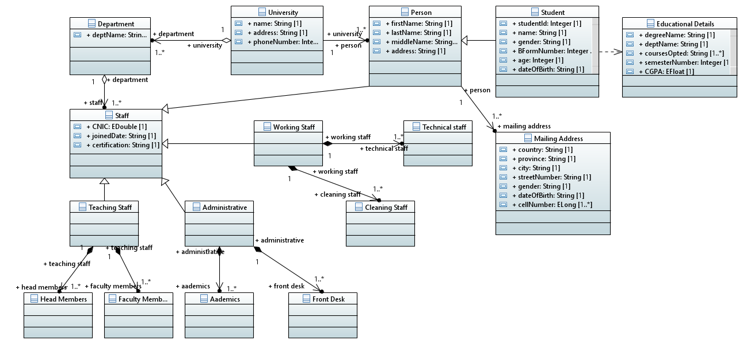

**Classes and Attributes:**

* University Class:

1. Name
2. Address
3. Phone number

* Department Class:

1. Department name

* Person Class:

1. First name
2. Last name
3. Middle name
4. Address

* Student Class:

1. Student ID
2. Name
3. Gender
4. B-Form number
5. Age
6. Date of Birth

* Education Details Class:

1. Degree name
2. Department name
3. Courses opted
4. Semester number
5. CGPA

* Mailing Address Class:

1. Country
2. Province
3. City
4. Street Number
5. Age
6. Gender
7. Phone Number

* Staff Class:

1. CNIC
2. Joined date
3. Certificate

* Working Staff Class:
* Administrative Class:
* Teaching Staff Class:
* Head Members Class:
* Faculty Members Class:
* Front Desk Class:
* Academics Class:
* Cleaning Staff Class:
* Technical Staff Class:

**Classes and Relationships:**

* University class has an aggregation relation with Departments’ class.
* Departments’ class has aggregation relation with Staff class.
* University class has association relation with Person class.
* Person class has generalization relation with Students’ class and Staff class.
* Student class has dependency relation with Educational details class
* Staff class has a generalization relation with Teaching staff class
* Teaching staff class has composition relation with Faculty member class and Head members class
* Staff class has a generalization relation with Administrative staff class
* Administrative staff class has composition relation with Front desk class and Academic manager class
* Staff class has a generalization relation Working staff class
* Working staff class has composition relation with Cleaning staff class and Technical staff class.